Karthik Nandula

0002 - Live Streams!

August 9th 2020

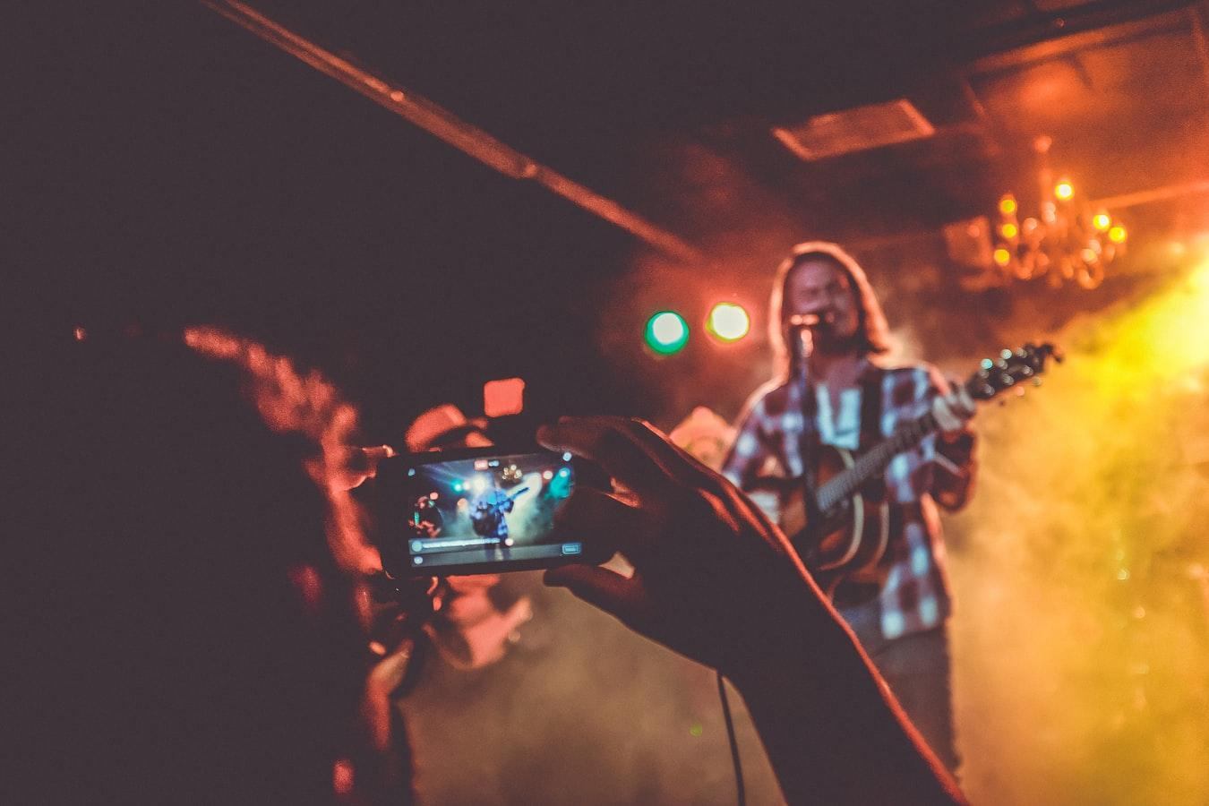

Recently, I have been doing a few study live streams on YouTube as a way to encourage myself to study. The idea came about when I was procrastinating consistently(lol) at the beginning of this week.

Then, I decided, my life needs reform.

Ok, maybe not that serious. Anyway, I saw some other live streamers on various platforms including Twitch and YouTube and was instantly inspired. I felt an urge to try it out myself! And I did. I’d like to share my thoughts on that…

### An Intro

Every time I see a YouTuber talking about creating content, I am allured to the idea! It doesn’t take a second for my mind to strike with thoughts of creating my channel full of videos. But why have I never done it?

I feel a subtle sense of fear for making my content public. This is unfortunate.

In the world that we’re living in, which is erupting with opportunities everywhere, I have questioned the thought multiple times. The thought of “*why should I make things public?*”. And having been inspired by various other creators who are making meaningful content - to name a few Ali Abdaal, Visakan Veerasamy and Vsauce - I have felt drawn into the idea more than ever before!

I’ve already briefly dipped into making things public in the [previous post](https://wiki.karsidonline.com/inception/), although there are multiple benefits.

### 1) You can reach out to your audience.

I suppose the biggest reason to make things public is that you can reach out to people who care about the content you like! You would never imagine that people are after your content. But if you haven’t publicised it in the first place, how would you know? When I say this, it may sound hypocritic. Although, from my ‘heroes’ of YouTube, this is where my opinion currently stands.

### 2) People like your style. You are a niche!

Yes. This is one of the most interesting ideas that has, again, captivated me to the ‘make it public(MIP)’ concept. I find that everyone has their style and perception of the world and with the vast population that we have, ideas and perspectives are such a diverse array that ‘everyone is their own niche’. This has prompted me to create my own style of content on YouTube by live streaming.

For example, on YouTube, you may have a video about a topic that already exists, though, your production quality, commentary, visualisation and descriptions will be different from others. This is what people are after! They want to look at your style of content and digest your ‘corner on the internet’. Man, I love paraphrasing!

### 3) What’s wrong with experimentation?

Ultimately, if you’re planning to start a project, what’s wrong with experimentation? Try it out and see if it goes in vain. It very rarely does vanish into thin air because if you can continue it for a while, consistency and quality will automatically dominate the algorithm and push you up the leaderboard. It’s easy for me to say. Hopefully, I can use this project and my YouTube live streams to demonstrate the possibilities.

Another point vaguely associated with this is that if you do feel suppressed by the idea that there’s already a lot of content out there, don’t be! We consume more than we create. It may seem as if there are lots of creators, however, this ties back into the above point… Everyone has their own style and you will always find space in the ever-expanding interverse(my version of Internet universe). I wrote about this in the [previous post](https://wiki.karsidonline.com/inception/) too.

### The Now

So, with that mentioned, let’s move onto what I’ve been venturing on. I started live-streaming a few study videos to get the initial snowball rolling. Now, I’m kinda enjoying it! I don’t care who watches me(ok, maybe I do a little bit) or how many people watch the videos. All I know is that I’m enjoying the documentation of me studying and that it’s a great way of self-reflection with perhaps a little value that others can benefit from. And because I have the notion that it *may* help somebody, I have been drawn to make it public.

### What do I plan to achieve out of it?

Well, there are actually several things although these are mere plans and not objectives that I treat as a to-do list.

**1) I mainly plan to create meaningful content.**

There is a lot of content out there! It’s a boundless ocean. However, I’d like to make my contribution valuable and not just junk. This doesn’t mean that I pour in hours to produce excellent content. It just means that I go at it with some clarity. When creating live streams, videos or writing blogs, I go at it with a nano plan and then it evolves into a topic of relative depth and suddenly becomes a ‘meaningful’ thought to document.

**2) I also plan to build an Internet community.**

The Internet is full of awesome people! The communities I’ve been establishing on various platforms, including Twitter, have allowed me to explore fascinating readers, avid programmers, aspirational writers and meaningful content procedures. This has driven me to produce great content and also learn from them! The opportunities for social media are boundless. They’ve allowed me to reach out to relatively popular people with rarely anything going! With that, I’ve been able to compile connections with great people and at occasions even arrange meetups! Unfortunately, the present situations hinder the possibilities of taking the connection to an actual meetup. Though there’s a technology for that too!

**3) LEARN, LEARN, LEARN!**

My ultimate ambition with the YouTube live streams or this million-word project is to learn about myself and acquire numerous skills along the way. They will take up a lot of my time, but, I’m willing to invest time for these invaluable skills. Additionally, one of the less-discussed topics is about how precious experience is to your personal growth. And these projects are no exceptions. They will certainly provide invaluable inputs for me to grow as a person and evolve. My belief is that with these roots reinforced, I can stretch my wings and fly high(I know, what a metaphor!) to really say, ‘the sky is the limit’!

Alright, it’s getting late so I’ll pause there. Until tomorrow, bye!